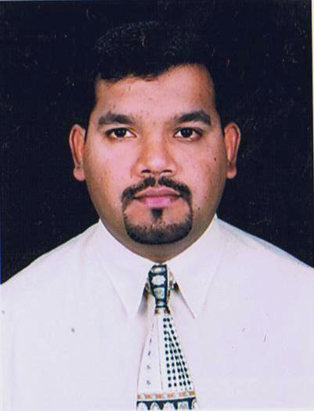
SHAKEEL AKHTAR SALEEM
Pakistani, 32yrs, Married, Male, P.O.Box: 19629, Dubai - U.A.E.
04 264 3 828 - 050 57 85 148
Holding valid U.A.E. driving license (3, 5 & 6). 1992
shaqeel007@hotmail.com
Objective
Seeking a carrier in an organization where I can learn, contribute, grow and climb to the corporate ladder of success there by shoulderingmore responsibilities.

Experience

Emirates Driving Institute - Jan 2005 - present
- Worked as an instructor on light vehicle (2005)
- Worked as an instructor on heavy bus (2006)
- Worked as a lecturer(safety lectures of driving)
- Presently working as an ITC instructor-training Centre, following (ADAS) course
Advanced Driving Automobile School, Bristol, London.

Dubai police - Mar 2004 - Jan 2005
Receptionist / information specialist

- Answered phones, greeted and assisted visitors and handled general administrative duties, such as filing, faxing, copying and mailing.
- Translate in various kinds of languages such as Arabic, English, Urdu, Balouchi and Punjabi.
- Familiar with written in English, Arabic and Urdu.
- Corresponded with customers.

Chauffeur - Feb 2003 - Feb 2004

- Delivered all kinds of cases in various departments in Dubai such as all police stations, Dubai municipality, all hospitals in Dubai, Dubai courts & free zones.
- Dubai naturalization and residence department, ministry of labour and ministry of education.

Other Experience
- Legalization of shipping documents for U.A.E. ministry of foreign affairs, chamber of commerce and various embassies / consulates.
- Worked in Dubai 2003 annual meetings of board governors of the world bank group and the international monetary fund as an coordinator C/O.Arabian adventures in Dubai International Airport.
- Worked in Alpha Tours, Dubai as aTour Guide for around a year duties include, City Tour, Future Tour, Safari, DhowCruise &East Coast Tour.
- Worked as car hiring clerk form 1993 - 1995 with Formula rent a car, Dubai.
- Worked as a P.R.O. in Al Abaq trading est. (1997), arranging business, transit, employment &
visit visas.
- Worked in Pine Cigarette as a salesman. (JAFZA)
- Worked in (M.B.M. Dallah – Al Ain) as a Transport Supervisor.

Education

- Imperial College, London
March 1995 - Bachelor of Business Administration (B.B.A.).

- G.C.E. "O" level, London University.

- High School Diploma (1990) Al Sadiq Islamic English School, Dubai.

Training & certifications

- Certificated in Intermediate Arabic - Dubai Police College.
- Certificated in Introduction to Arabic level - British Council, Dubai.
- Certificated in United Nations, 22nd Worldwide Information.
- Certificate of Appreciation by Emirates Group Security.
- Certificated in Logistics & Supply Chain Management – Aptech Centre, Dubai.
- Certificated of“The Work on Road Alerts” from International Association for Human Values
under the patronage of Dubai Police & RTA.

Computer Skills

- Microsoft word
- Microsoft Excel
- Power Point
- Dbase III plus
- Well versed with usage of Internet & email.

Languages

- English - fluently
- Arabic - fluently
- Urdu – fluently
- Balouch– fluently
- Punjabi - fluently

I would like to apply for the suitable post in your organization. I am enthusiastic & hard working individual with excellent interpersonal & communicational skills with the ability of getting whatever work entrusted to me done.

Hoping to hear from you soon.
Thanks & best regards

SHAKEEL AKHTAR SALEEM

