

Yahoo Awards Center

Yahoo Awards Center

124 Stockport Road, Longsighted, Manchester M60 2DB - United Kingdom

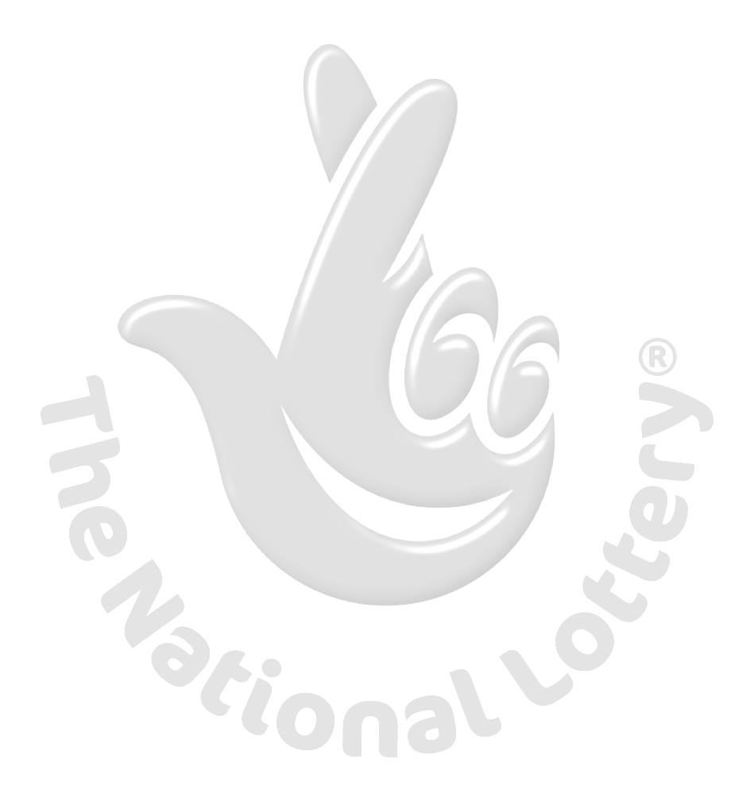
This is to inform you that you have won a prize money of One Million British Pounds (£1,000,000.00) for 2010 Prize promotion which is organized by YAHOO, AOL & WINDOWS LIVE every (2) yrs. YAHOO and MICRO SOFT collects all the email addresses of the people that are active online, among the millions that subscribed to Yahoo and Hotmail and few from other e-mail providers. Six people are selected every two years to benefit from this promotion and you are one of the Selected Winners.
PAYMENT OF PRIZE AND CLAIM.
Winners shall be paid in accordance with his/her Settlement Center. Yahoo Prize Award must be claimed no later than 28th days, from date of Draw Notification. Any prize not claimed within this period will be forfeited. Stated below are your identification numbers: BATCH NUMBER: MFI/08/APA-43658, REFERENCE NUMBER: 2008234522 PIN: 1208 WINNING NUMBER: 01 14 21 30 35 48 These numbers fall within the Johannesburg Location file, you are requested to contact our fiduciary agent in Johannesburg South Africa and send your winning identification numbers to him:

CLAIMS MANAGER CONTACT INFORMATION:
NAME: Dr NELSON EDWARD
E-MAIL: drnelsonedward@gala.net
TEL: +27- 832-459-925
You are advised to send the following information to your Claims Agent to facilitate the release of your fund to you.
1. Full name......
2. Country................................………………..
3. Contact Address...................………………..
4. Telephone Number...............……………….
5. Fax Number.... ......................………………
6. Marital Status.......................……………….
7. Occupation...........................……………….
8. My Date of birth...................………………
9. Sex...............................………………………
10. Batch Number...............................……….
11. Reference Number.................................
12. Pin Number..............................………….
13. Winning Number..............................…..
14. Amount Won..............................………..
15. Please note that a copy of your passport or your drivers license is needed while sending your information.

Congratulations!! Once again.

Yours in service,

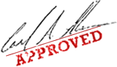
Dr. (Mrs.) Mercy Martins
WARNING!
You may also receive similar e-mails from people portraying to be other Organizations of yahoo Inc. This is solely to collect your personal information from you and lay claim over your winning. In event that you receive any e-mail similar to the notification letter that was sent to you, kindly delete it from your mailbox and give no further correspondence to such person or body. Yahoo shall not be held responsible for any loss of fund arising from the above mentioned. PLS SEND YOUR REPLY TO YOUR CLAIMING MANAGER EMAIL ADDRESS: drnelsonedward@gala.net

