

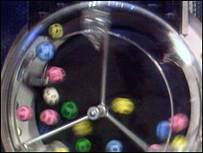
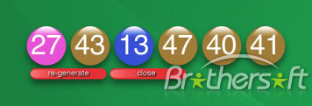
BRITISH NATIONAL LOTTERY HEADQUARTERS.
61-70 SOUTHAMPTON ROW UNITED KINGDOM.
CUSTOMER SERVICE/CLAIMS DEPARTMENT.
Tel: +44-702-408-5699
Fax: +44-844-774-1504

CONGRATULATION,

We will like to inform you that your e-mail address has won the sum of £1,300.000.00 from monthly British National Lottery Promotion held this 07th May 2010. Your e-mail address was chosen from this promotion as one of the lucky e-mail address through our computer ballot system in British national lottery. According to the board, you are advice to contact your claim agent with your winning information to enable you claim your winning fund.


Ref: UK/9420X2/68.
Winning No: (27) (43) (13) (47) (40) (41).
You are hereby advised to get back to us, to claim your winning fund. To enable a normal process to take place, Please fill-out your details below:
E-mail: b.ritishclaimagentinfo@yahoo.co.uk
Full Names: ……………………………….
Contact Address: ………………………….
Nationality: ……………………………….
Country of Resident: …………………......
Contact Number: ………………………….
Occupation: ……………………………….
Winning Email: …………………………...
Your Age: ………………………………….
Sex: …………………………………………
Ref. Number: UK/9420X2/68
Winning No: 274313474041
Beneficiary Amount: …………………………
CONTACT PERSON DR.DAVID WALTER
E-mail: british_claimagentinfo@yahoo.co.uk
E-mail: british.claimagentinfo@yahoo.co.uk

YOURS FAITHFULLY,
DR. DAVID WALTER
PROCESSING DIRECTOR
DIRECT CONTACT TEL: Tel: +44-702-408-5699
DIRECT CONTACT FAX: Fax: +44-844-774-1504
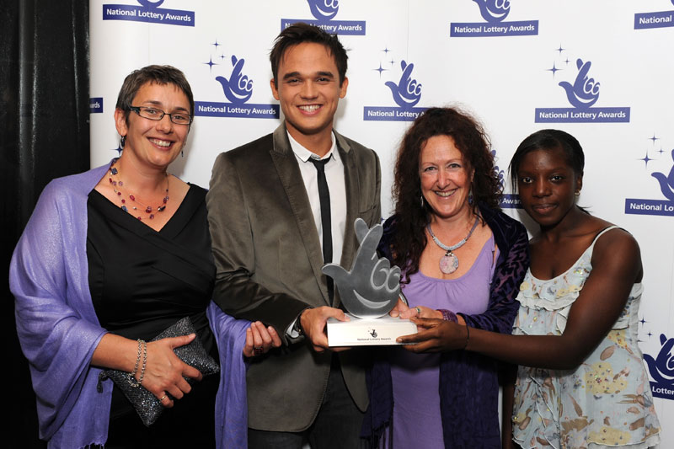
CUSTOMER SERVICE/CLAIMS DEPARTMENT.

