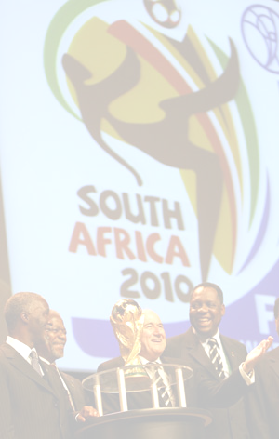

CONGRATULATIONS WINNING NOTIFICATION!!!
SOUTH AFRICAN 2010 FIFA WORLD CUP LOTTERY AWARD

The Continental-Million Lottery (CML) Promotion team is proud to inform you that you have won US$1,100,000.00 (One Million One Hundred Thousand United State Dollars) why you have won? Your E- mail address is one of 7 lucky Addresses who have won in the weekly Promotion.
See below how to claim your prize.
Details on the Winnings
Your Winning Reference Number is: CML/240142:
Batch Number18/006/1094/LIPDA/ZA
WINNING NUMBERS: 80, 35, 11, 72, 90, 41 (01)
Send the following information below:
Details on the Winnings FULL NAME:
COUNTRY:

COUNTRY OF RESIDENT:
CITY:
AGE:
SEX:
MARITAL STATUS
OCCUPATION:

COMPANY:
MOBILE:
WINNING EMAIL:
FULL ADDRESS:

Note: This program is being sponsored by the FIFA SUPPORT TEAM to create awareness for the up Coming 2010 FIFA world Cup, which is to be host by South Africa.
TO FILE FOR YOUR CLAIM...
Contact The Claim Processing Manager:
Mr. Ike Ndlovu
TEL: +27 835260979
FAX: +27 866 127632
Email: megamillionmoney@live.co.za
http:// www.fifa.com/worldcup/

The Continental -Million Lottery Promotion team congratulates once you again on your winning.
Yours Faithfully,
Mrs. Teresa Botha
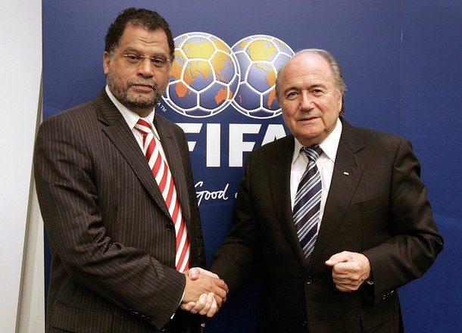

(Zonal Co-coordinator Sec.)

