


CANADIAN LOTTERY ONLINE LUCKY PROGRAM (LOTTO MAX)
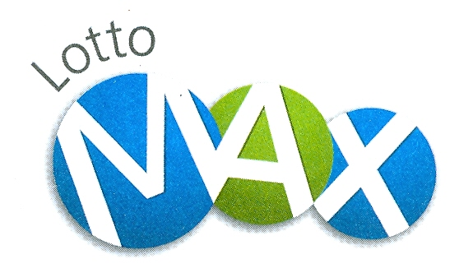

No.33 Bloor Street East
Toronto Ontario Canada

Dear Winner No.2

YOU ARE A GUARANTEED WINNER OF US$850,000.00
EIGHT HUNDRED AND FIFTY THOUSAND UNITED STATES DOLLARS


Congratulations! Your email address have won US$850, 000.00 (Eight Hundred and Fifty Thousand United States Dollars) in the Canadian Lottery Online Lucky Program (Lotto Max) held on Friday March 26, 2010 in Ontario Canada to promote and support the 2010 FIFA World Cup South Africa (the first time the world's biggest sporting event is coming to Africa and the first world cup event on African soil) co-sponsored by the Canadian Government.

Your email address selected from the World Wide Web "WWW" (Microsoft Powered) through our online computerized email selection system drew the winning numbers 03 11 12 16 34 36 37 Bonus 18, which you subsequently won the lottery in the 2nd category. You have therefore been approved to claim a total sum of US$850, 000.00 (Eight Hundred and Fifty Thousand United States Dollars). To claim your winning prize please contact our agent in Southern Africa where your lucky winning number falls immediately you read this message via telephone, fax or email address below:-

Company Name: J J I GROUP - Financial Services
Contact Person: Mr. Alpha Bruce
Tel: +27-83-313-3458
Fax:+27-86-612-1595
Email: jjigroupfssa@hotmail.co.za

Batch No: 4CLOLP866QXX0-0-10XXZA
Reference No: 4800CLZA-QJ-0-0-10ZA
Serial No: 1893MZX10
Ticket No: 8882CLOLPXXZA

This promotion aimed at internet globalization before the year 2010 thereby empowering internet literacy against monopoly in which email addresses were used therefore you do not need to buy ticket to enter for it.

Best wishes,

Mrs. Tracy Walter
Promotional Manager

Note: To confirm that your email address drew the winning numbers for Friday March 26, 2010 draw visit our website
http://www.canada.com/life/lotteries/lottery_results.html
All rights reserved. Terms of Service - Guidelines


©1999-2010 by CLOLP Lotto Max

