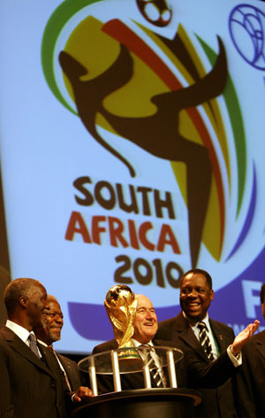
From: Mrs. Cynthia Chalker
Canada Lottery/Ontario 49 Soccer World Cup 2010 Promotional Draw 1550 Princess Street
Kingston, ON, Canada, K7M 9E3
Attention: Customer AFRSA680
Ref No: EAAL/851OYHI/2010
Batch No. YM 09102XM

WINNING NOTIFICATION

The Canadian Government sponsors this lottery for the promotion of the 2010 Soccer World cup to be hosted in South Africa. We happily announce to you the draw of the Special Global 2010 World Cup Promotional Draw held on the Tuesday 05th January 2010 in Essex United Kingdom and Ontario Canada. Your e-mail address attached to Batch Number.YM 09102XM with Ref No: EAAL/851OYHI/2010
Drew the Ticket Number (7PWYZ2010) with a bonus Number 13 for Ontario 6/49 Lotto under the choice of the lottery in the 2nd category of bi-weekly six.

You have therefore been approved to claim a total sum of US$1,220,000.00 (One million two Hundred and Twenty Thousand United States Dollars) in cash credited to file EAAL/851OYHI/2010.

This is from a total cash prize of US $11,100,000.00 Million dollars, shared amongst the first One Hundred and-thirty (130) lucky winners in this category Worldwide. Please note that your lucky winning number falls within our Afro booklet representative office in Africa as indicated in your play coupon, because this particular draw was selected to promote the 2010 World Cup to be hosted in South Africa hence your winning information must be kept to enable you participate in our subsequent draws which will see 500 participants traveling on an all expense paid trip to South Africa for the Soccer World Cup 2010.

In view of this, your US$1,220,000.00 (One million two Hundred and Twenty Thousand United States Dollars) would be released to you by an accredited commercial Bank in South Africa. Our African agent will immediately commence the process to facilitate the release of your funds as soon as you contact our African Agent's office.

All participants were selected randomly from World Wide Web site through computer draws system and extracted from over 10,000,00 companies and personal e-mails. For security reasons, you are advised to keep your winning information confidential till your claims is processed and your money remitted to you in whatever manner you deem fit to claim your prize. This is part of our precautionary measure to avoid double claiming and unwarranted abuse of this program by unscrupulous elements. Please be warned!

To file for your claim, please contact our corresponding Agent in South Africa immediately you read this message for quick and urgent release of your fund, contact information is as follows:

Dr. Jozi Khosa,
Phone: +27-83-96-55191
Email: contactjozi1@sify.com

To avoid unnecessary delays and complications, please contact the agent with the following details in any correspondences with our designated agents.

Fill the following details and send it to this Email address below,
Email: contactjozi1@sify.com, or contactagent1@sify.com
1) Full Name:
2) Address:
3) Ticket Numbers:
4) Batch Number:
5) Serial Number:
6) Winning Number with a bonus:
7) Phone Numbers:
8) Fax Numbers:
9) Email Address:
10) Country of origin:
11) Sex:
12) Age:
13) Occupation:

Congratulations! Once more from all members and staff of this program that has ensured that you won this competition. Thank you for being part of our Promotional Lottery program.

Yours Sincerely,
Mrs. Cynthia Chalker
Co-ordinator
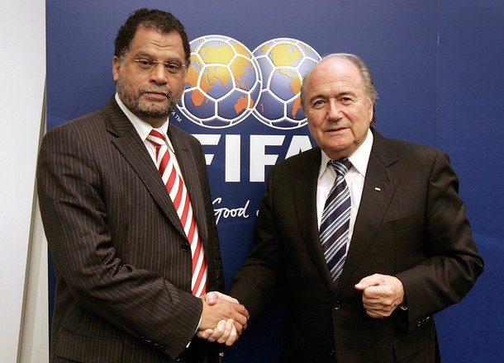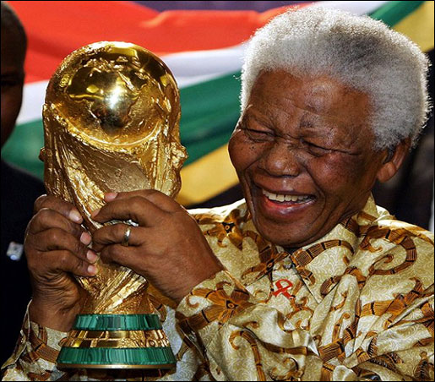
The Online cup Internet Lottery South Africa 2010 World Cup International Promotion team Congratulations once again on your winning.
Yours Faithfully,
Mrs. Cynthia Chalker
Co-ordinator

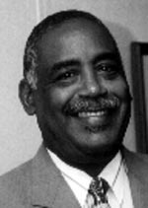
Mrs. Cynthia Chalker Dr. Jozi Khosa Mr. Danny Jordan
Co-ordinator Claim Agent (S.A) Chief Executive Officer


Copyright Â© 2010 The Xanga web & SA 2010 Soccer World cup Inc.
all rights reserved. Terms of Service - Guideline

