
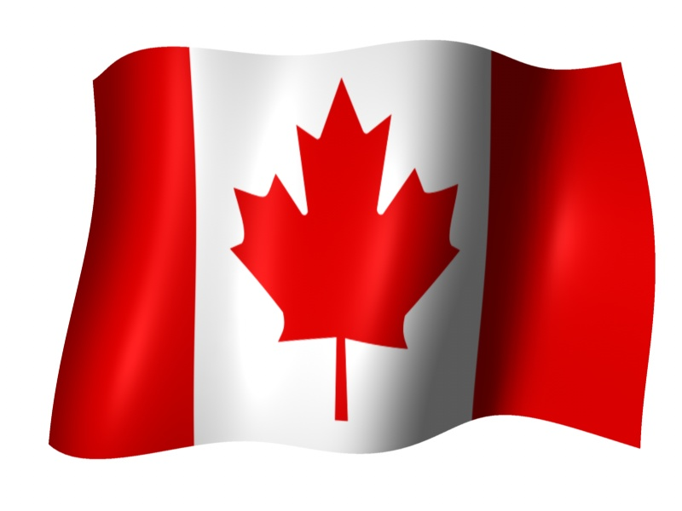

CANADIAN LOTTERY AWARD DRAWS ONTARIO 49
Tel/Fax: +1 330 232 7551
E-mail: ontario49lotterydraw@winning.com
Address: 1550 Princess Street Kingston, ON, Canada, K7M 9E3
http://www2.canada.com/findit/lotteries/results.aspx?id=8

CANADIAN AWARD NOTIFICATION

The Canadian Lottery company happily announce to you that your e-mail address has won you the sum of US$1,000.000.00(One Million, United States Dollars Only)on the draw (#1659) Ball Set Used: 5 of the Online data International program held on Canada July 2009 and was officially Announced your e-mail address attached to ticket number: 877633070621 with Serial number:CAL0076 drew the lucky numbers: (18)-(20)-(28)-(33)-(34)(bonus ball no.38), which subsequently won you the lottery in the 2nd category i.e Web; http://www2.canada.com/findit/lotteries/results.aspx?id=8

Match 5 plus bonus. You have therefore been approved to claim a total sum of US$1,000.000.00(One Million, United States Dollars Only).

This is from a total cash prize of US$7,000.000.00 shared amongst the (7) jackpot lucky winners in this category i.e. match 6.All Participants for the online version were selected randomly from World Wide Web sites through computer draw system and extracted from over 100,000.000 unions, associations, and corporate bodies that are listed online which are America, Africa, Asia, Australia, Europe, Middle East, and Oceania.

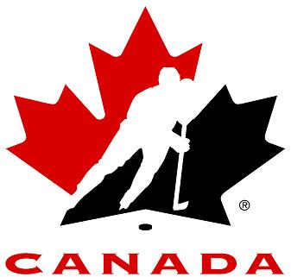
Please note that your lucky winning number falls within our Europe booklet representative office as indicated in your play coupon. In view of this, you have therefore been approved to claim a total sum of you have therefore been approved to claim a total sum of US$1,000.000.00(One Million, United States Dollars Only). Would be released to you by any of our payment offices in United Kingdom they will commence the process to facilitate the release of your funds As soon as you contact them. For security reasons, you are advised to keep your winning information confidential till your claims is processed and your money remitted to you in whatever manner you deem fit to claim your prize. This is part of our precautionary measure to avoid double claiming and unwarranted abuse of this program. Please be warned. To file for your Claim, please contact our claim services centre in United Kingdom with the below details:

Canadian National Lottery Claim Service Centre
Address: UK Office No 47 Se1 7na – Balking London
United Kingdom
E-mail: canadaawardrepresentative@gmail.com
E-mail:canadadrawpayout@gmail.com
Tel/Fax: +44 870 495 8760

For further clarification/verification of your claims, Please call any of the phone number of our Claim Service Centre or send your details through e-mail . You can go to our online result site to confirm the value of your winnings and also get a prize breakdown.

Good luck and congratulation from all members of staff of the Canadian Lottery Award Draws Ontario 49

Yours faithfully,
Mr. Godwin Hudson
Online coordinators for Canadian Lottery Award Draws Ontario 49
International Award Program

All lottery results are unofficial. Please check with your local lottery retailer for confirmation.
Copyright © 2000 - 2009 LotteryCanada.com. All rights reserved

