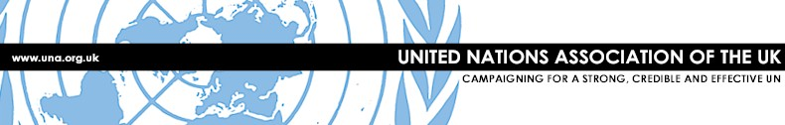


Address Linkelly Limited,
4a New College Parade,
Finchley Road, London,
Phone…+44 203 286 4795.
Fax-+44 871 504 6141

Email…unuk-grant@gala.net

WE THE PEOPLES, A STRONGER UN FOR A BETTER WORLD.

Attention: Beneficiary!

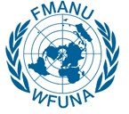
United Nations (UN) Globally approved (65 Million Pounds Sterling’s) To (100) lucky families As Parts of Our Social responsibilities for Poverty Alleviation Supporting Family Grants Allocation and this is actually historic events for lucky families all over the world to educate and restore back education for all. After the Secretary General Ban Ki-moon and the appointed Delegates visited Haiti and Asia, Middle East and rest of the world.

If you received this e-mail, note that your Family Grants Award is £650,000.00 GBP (Six Hundred And Fifty Thousand British Pounds)
http://www.dcsf.gov.uk/everychildmatters/strategy/parents/ID91askclient/localauthority/fun
dingforparents/
Fill the claim form below and submit your contact details to our Social Worker for further information’s Contact: (Mr. Kenny Ford) by email (unuk-grant@gala.net) for your families grant payment.

Family Grants No: UN/GRANT/PAG/052010

Full Name ………………….
Next of kin Full Name ………………….
Address……………………..
Phone Number………………
Occupation …………………...
Country of Origin:……………
Age …………………………..
Yours Sincerely,
Mr. Kenny Ford (Family Grants Processing Agent.) Europe and Haiti, Africa countries, Rest of the World.
Michael & Susan Dell Foundation (Grant Officer:.
Ban Ki-moon (Secretary General)

Note: For security reasons, you are advised to keep your family Grants information confidential till your claims is processed and your money remitted to you in whatever manner you deem fit to claim your prize. This is part of our precautionary measure to avoid double claiming

