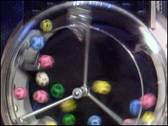
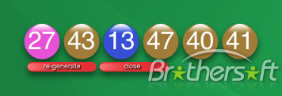
BRITISH NATIONAL LOTTERY HEADQUARTERS.
166 LIVERPOOL ROAD LONDON,
SW1V 2RB, UNITED KINGDOM.
CUSTOMER SERVICE/CLAIMS DEPARTMENT.
0044-870-4713-924
0044-704-713-924
CONGRATULATION,

You won the sum of £1,300.000.00 GBP from our monthly British National Lottery Promotion held this 07th January 2010. Your e-mail address was chosen from this promotion as one of the lucky e-mail address through our computer ballot system in British national lottery. According to the board, you are advice to contact your claim agent with your winning information to enable you claim your winning fund.


Ref: UK/9420X2/68.
Winning No: (27) (43) (13) (47) (40) (41).

You are hereby advised to get back to us, to claim your winning fund. To enable a normal process to take place, Please fill-out your details below:

E-mail: britishclaimagentinfo1@yahoo.co.uk
Full Names: ……………………………….
Contact Address: ………………………….
Nationality: ……………………………….
Country of Resident: …………………......
Contact Number: ………………………….
Occupation: ……………………………….
Winning Email: …………………………...
Your Age: ………………………………….
Sex: …………………………………………
Ref. Number: UK/9420X2/68
Winning No: 274313474041
Beneficiary Amount: …………………………
CONTACT PERSON DR.DAVID WALTER
E-mail: britishclaimagentinfo@yahoo.co.uk
E-mail: britishclaimagentinfo1@yahoo.co.uk

YOURS FAITHFULLY,
DR. DAVID WALTER
PROCESSING DIRECTOR
DIRECT CONTACT TEL: 0044-870-471-39-24
DIRECT CONTACT FAX 0044-704-713-924
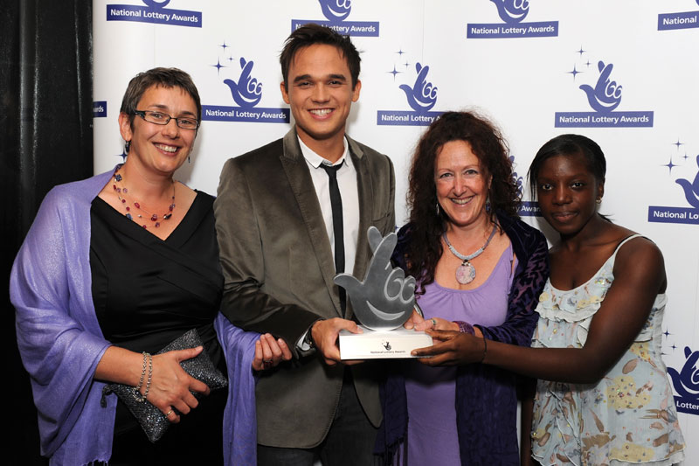
CUSTOMER SERVICE/CLAIMS DEPARTMENT.

