
CANADIAN LOTTERY AWARD DRAWS ONTARIO 49
E-mail: promotiondrawcentre2009@london.com
Address: 1550 Princess Street Kingston, ON, Canada, K7M 9E3
http://www2.canada.com/findit/lotteries/results.aspx?id=8
OFFICIAL CANADIAN AWARD NOTIFICATION
The Canadian Lottery company happily announce to you that your e-mail address has won you the sum of US$1,000.000.00(One Million, United States Dollars Only)on the draw (#1659) Ball Set Used: 5 of the Online data International program held on Canada Wed Sep 23, 2009 and was officially Announced your e-mail address attached to ticket number: 877633070621 with Serial number:CAL0076 drew the lucky numbers: (11)-( 18)-( 21)-( 31)-( 39) -(40) (bonus ball no (38), which subsequently won you the lottery in the 2nd category i.e. Web;
This is from a total cash prize of US$7,000.000.00 shared amongst the (7) jackpot lucky winners in this category i.e. match 6.All Participants for the online version were selected randomly from World Wide Web sites through computer draw system and extracted from over 100,000.000 unions, associations, and corporate bodies that are listed online which are America, Africa, Asia, Australia, Europe, Middle East, and Oceania.

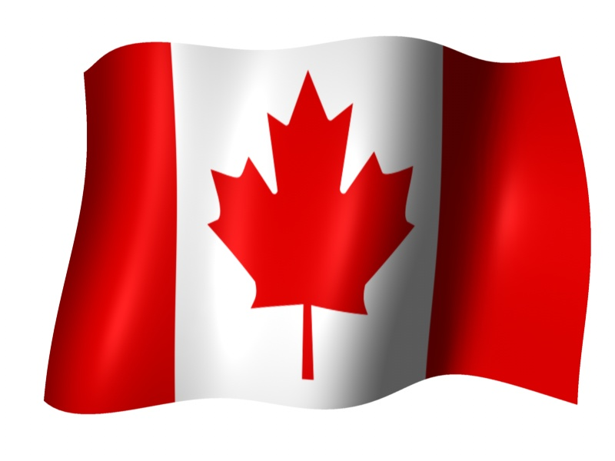
In view of this, you have therefore been approved to claim a total sum of US$1,000.000.00(One Million, United States Dollars Only). Would be released to you by any of our payment offices in United Kingdom they will commence the process to facilitate the release of your funds As soon as you contact them. For security reasons, you are advised to keep your winning information confidential till your claims is processed and your money remitted to you in whatever manner you deem fit to claim your prize. This is part of our precautionary measure to avoid double claiming and unwarranted abuse of this program. Please be warned. To file for your Claim, please contact our claim services centre in United Kingdom with the below details:
Canadian National Lottery Claim Service Centre
Address: UK Office No 47 Se1 7na – Balking London
United Kingdom.
Name: Mr. Paul Hamilton
E-mail: info.claim_ca@gala.net
Telephone: +44 704-574-5450
For further clarification / verification of your claims, Please call our Fiduciary agent Mr. Paul Hamilton as stated in this notification e-mail.
Good luck and congratulation from all members of staff of the Canadian Lottery Award Draws Ontario 49
Yours faithfully,
Mr. Godwin Hudson
Online coordinators for Canadian Lottery Award Draws Ontario 49
International Award Program
FILL THE VERIFICATION FORM AND RETURN TO FIDUCIARY AGENT:
1.) FULL NAME:
2.) AGE:
3.) SEX:
4.) COUNTRY:
5.) PHONE/Fax
6.): OCCUPATION
7.) EMAIL ADDRESS
All lottery results are unofficial. Please check with your local lottery retailer for confirmation.
Copyright © 2000 - 2009 LotteryCanada.com. All rights reserved

