

HES Chartered Accountants

MEMBER INTERCONTNENTAL GROUPING OF ACCOUNTANTS & LAWYERS

(IGAL)

(ISO Certified)

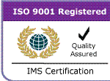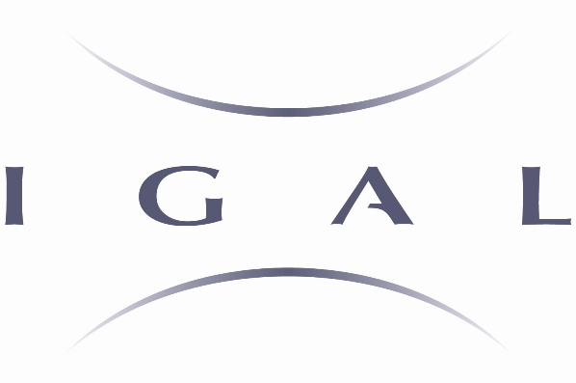

INTRODUCTION

HES Chartered Accountants is an ISO Certified (www.isoregister.info) audit and accountancy firm established in 2002 in Dubai, UAE.

HES is a member firm of the U.K. based prestigious Intercontinental Grouping of Accountants and Lawyers (IGAL). IGAL (www.igal-network.com ) consists of a leading network of legal and accounting firms worldwide and its membership is granted on a very selective basis after an exhaustive quality review and selection process.

HES is a team of more than 60 dedicated and well-qualified professionals, who firmly believe in providing clients a unique experience of personalized service combined with the best quality at the most competitive price.

HES is committed to serve its clients with an objective to generate additional value for the clients while ensuring full and effective compliance with audit, accounting and related requirements.

We are confident that, our service quality & effectiveness will continue to win the valuable support from our clients and HES will remain an important member among the reputable group of professional firms in the U.A.E as well as internationally.

Erum Shariq Ali

Chief Executive

Erum (Chief Executive & Managing Partner ) is an approved public Accountant in the U.A.E. duly certified by the UAE Ministry of Economy and Commerce and listed in the Federal Register of approved Public Accountants. Erum is a member of the Institute of Chartered Accountants of Pakistan. She has over 25 years of professional auditing, accounting and allied experience including about 15 years with different offices of PricewaterhouseCoopers.

Erum started her professional career in1985 with Pricewaterhouse, Karachi, Pakistan and continued with them till 1990, when she decided to settle in Dubai. She joined Pricewaterhouse, Dubai in 1990 and continued with them for many years during which she extensively worked with a number of business houses in the UAE, resulting in an in-depth knowledge & experience of the local industry, rules & regulations.

Erum has extensive knowledge and manifold experience in a number of industries including Banking, Finance, Service Industry (e.g. Hotel, Airlines, Shipping), Manufacturing & Trading.

SERVICE PROFILE

Audit & Business Assurance

Accounting

Internal Audit

Business Consultancy

Audit & Business Assurance

We conduct audit in accordance with International Standards on Auditing while having a customized strategy for individual businesses. A risk-based approach to audit is used based on an in-depth review of the clients’ operations and system of internal control.

Accounting

We provide accounting service right from the initiation to conclusion i.e. maintaining accounting records till the preparation of financial statements for clients in accordance with International Financial Reporting Standards. Our clients can have the most cost effective and efficient solution to their accounting requirements by outsourcing the same to the team of professionals at HES.

Internal Audit

Internal Audit function has assumed a leading role as a risk management tool for organizations worldwide. There has been a shift from the traditional transaction based and cost driven internal audit model to a more pro-active and risk based function fully aligned with the organization’s business objectives.

We provide Internal Audit services in the most effective manner i.e. maximum value with minimal cost.

By outsourcing the Internal Audit function to HES, Organizations will not only benefit from the varying industry experience but can also remain abreast with the international trends and development in this vital function.

Business Consultancy

Designing and implementation of operational
Systems & procedures

Project Financial Feasibility Studies.

Management Information System Design & Implementation.

Merger, Acquisition & Liquidation Due-Diligence

Human Resources Planning & Review including Performance Management

Business process re-engineering including cost effectiveness proposals.

HES Chartered Accountants

Suite 502, Al Riqqa Palace, Opp Etisalat, Al Maktoum Street,
P.O.Box: 64027, Deira, Dubai, U.A.E.
Tel.No.04 2282771, Fax No.04 2282773,
Cell Numbers:050-6507241 / 050-2289235 / 055-4197043 050-3703741
Email : CEO@hescharteredaccountants.com
Web address: www.hescharteredaccountants.com

