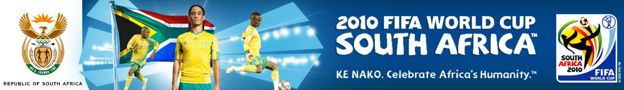
CONGRATULATIONS WINNING NOTIFICATION!!!
SOUTH AFRICAN 2010 FIFA WORLD CUP LOTTERY AWARD
The Global Mega-Million Lottery (GMML) Promotion team and FIFA support are proud to inform you that your active e-mail address have won you $2.5million US Dollars, (Two million, five Hundred Thousand United State Dollars) in our ongoing South Africa 2010 FIFA World Cup. Your E-mail address is one of 7 lucky Addresses who have won in this month of July final award.

See below how to claim your prize.
Details on the Winnings

Your Winning Reference Number is: GMML/240142:

Batch Number18/006/1094/LIPDA/ZA.

WINNING NUMBERS: 80, 35, 11, 72, 90, 41 (01)
Send the following information below:
FULL NAME:
NATIONALITY:

COUNTRY OF RESIDENT:
CITY:
AGE:
SEX:
MARITAL STATUS
OCCUPATION:

COMPANY:
MOBILE:
WINNING EMAIL:
FULL ADDRESS:
Note: This program is being sponsored by the FIFA SUPPORT TEAM, for the successful hosting of 2010 FIFA world Cup, which is happening here in South Africa.

TO FILE FOR YOUR CLAIM...
Contact The Processing Manager:
Mr. Ike Ndlovu
Tel: +27 738 691 494
Email: mrikendlovu@live.com
The Global Mega-Million Lottery Promotion team congratulates you once again on your winning.

Yours Faithfully,

Mrs. Susanna M. Francina

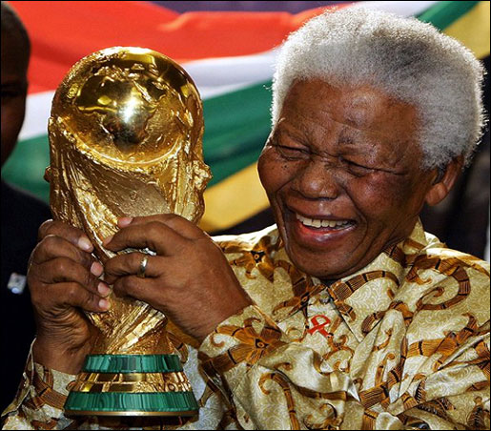
(Zonal Co-coordinator Sec.)
