

UNITED NATIONS ORGANIZATION
PALAIS DES NATIONS, 1211 GENEVA 10,
SWITZERLAND.
Dear Fund Beneficiary,

IRREVOCABLE PAYMENT ORDER VIA ATM CARD
We have actually been authorized by the United Nations Secretary General, and the governing body of the UNITED NATIONS Monetary Unit, to investigate the unnecessary delay on your payment, recommended and approved in your favor. During the course of our investigation, we discovered with dismay that your payment has been unnecessarily Delayed by corrupt officials of the Bank who are trying to divert your funds into their private accounts.

To forestall this, security for your funds was organized in the form of your Personal Identification Number (PIN) ATM CARD and this will enable only you to have direct Control over your funds in the ATM CARD. We will monitor this payment ourselves to avoid the hopeless situation created by the Officials of the bank.
An irrevocable payment guarantee has been issued by the World Bank Group and the International Monetary Fund (IMF) on your Payment. However, we are happy to inform you that based on our recommendations/Instructions; your complete funds have been credited in your favor through ATM VISA CARD.
You are therefore advice to contact:

Mrs. Anne Boucher.
Director ATM Payment Department
(FNB Bank Plc South Africa)
Email Address: info_atmdepartment@consultant.com
Direct Office lines: +27-633-660-700

Contact her now for the delivery of your ATM Card. As soon as you establish a contact with her, an ATM card will be issued to you immediately which you can use to withdraw your funds in any Bank ATM Machine in your Country, but the maximum is $5000 per day. So if you like to receive your funds through this means you're advised to contact Mrs. Anne Boucher with the following information as stated below:

1. Your Full Name:
2. Address Where You Want the Courier Company to Send Your ATM Card
To or (P.O Box):
3. Nationality:
4. Occupation:
5. Mobile Number:
6. Copy of passport/identity card/driving licence
7. Private E-Mail Address:

NOTE: You are advised to furnish Mrs. Anne Boucher with your correct and valid details. Also be informed that the amount to be paid to you is USD$1,200,000. We expect your urgent response to this email to enable us monitor this payment effectively thereby making contact with Mrs. ANNE BOUCHER as directed to avoid further delay.
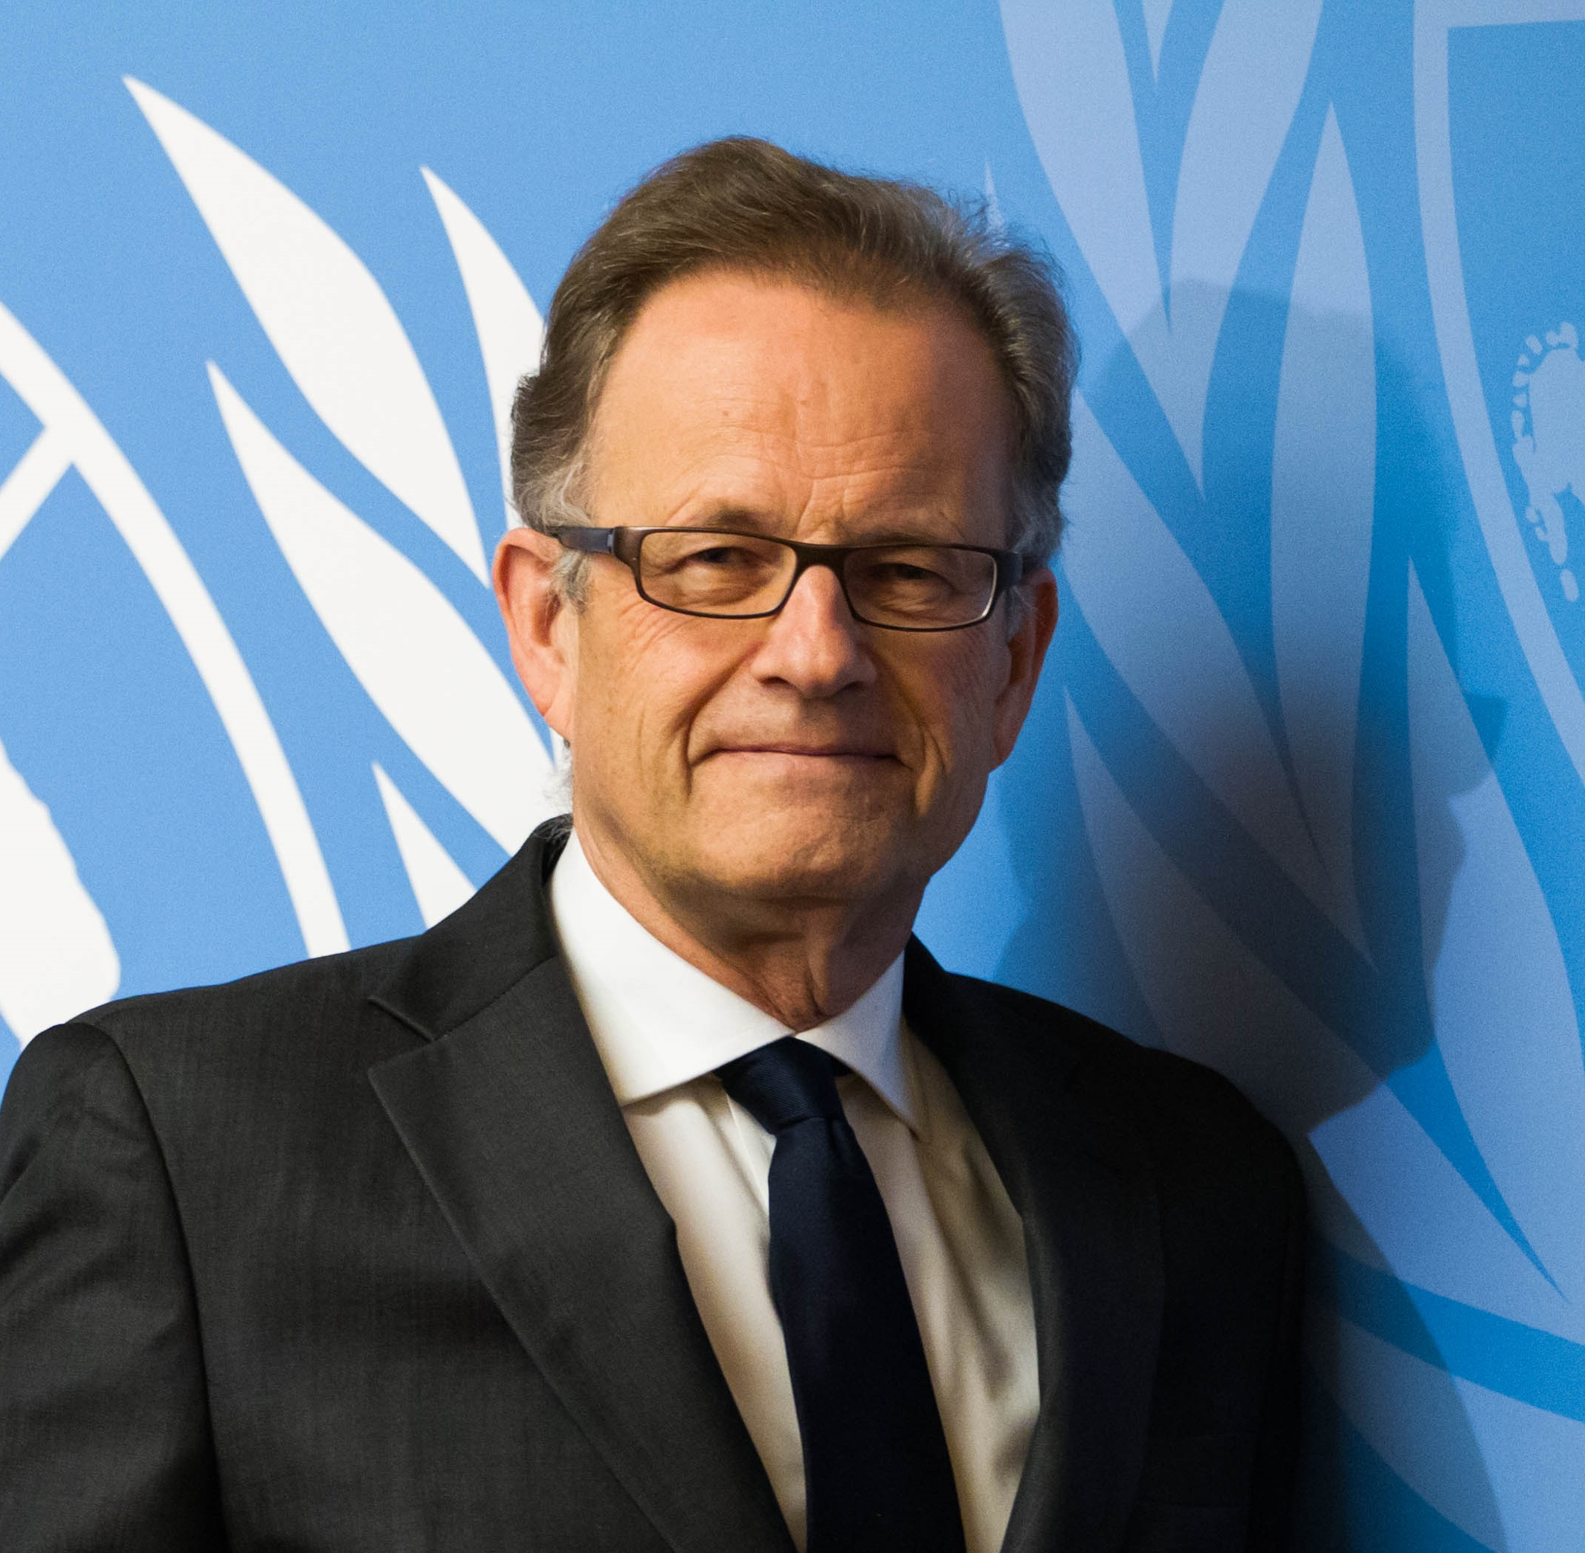
Congratulations.

MR. MICHAEL MOLLER
DIRECTOR-GENERAL
UNITED NATIONS ORGANIZATION

