
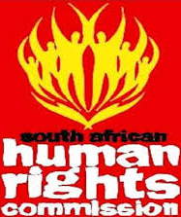
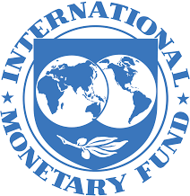


Dear Email Owner/Fund Beneficiary,

IRREVOCABLE PAYMENT ORDER BY ATM VISA CARD OR BANK TO BANK TRANSFER!

This message is directed to you based on the letter we received from South African Human Rights Commission (SAHRC), United Nations (UN) and International Monetary Fund Agency (IMF) regarding the settlement of all Lottery Winners and Inheritance Funds Beneficiaries in Africa.

This morning we have officially been authorized by International Monetary Fund (IMF) and United Nations (UN) (António Guterres) new United Nation Secretary General who took office in January 2017 to contact you for your overdue payment of $280,000.00 USD (Two Hundred and Eighty Thousand United States Dollars Only).

This is the third time your payment file has come to our table and every time an executive order will come from above ordering us that your fund should be recalled back to the World Bank Escrow account, without any genuine reason, but now our Payment Settlement System (PSS) has received another permanent Authority/Irrevocable Payment Release Order to pay you off your overdue payment of $280,000.00 USD (Two Hundred and Eighty Thousand United States Dollars Only).via ATM VISA Card or Bank to Bank Transfer.

Also note that from the record in your file, your payment of $280,000.00 USD (Two Hundred and Eighty Thousand United States Dollars Only) with Reference No. 35460021, Allocation No: 674632, Password No: 339331,Certificate of Merit Payment No: 103, Fund Released Code No: 0763, Telex Confirmation No: 1114433 and Secret Code No: XXTN013, having received all these vital payment numbers, therefore you are qualified now to receive and confirm your payment through our AFRICAN PAYMENT BOOKLET OFFICE IN SOUTH AFRICA.

CONTACT YOUR PAYMENT RELEASE OFFICER IN SOUTH AFRICA:
CONTACT NAMES: MISS. AMANDA HOLMES
POSITION HELD: PAYMENT RELEASE OFFICER
DIRECT TELEPHONE: +27 (0) 78 482 4450
EMAIL ADDRESS: amandaholmes.pro2020@mail.com

Do use the above information to contact her with your below requested information and indicate to her how you would like to receive your funds through this means of ATM VISA CARD or through BANK TO BANK TRANSFER. You are advised to contact (MISS. AMANDA HOLMES) with the requested below information:

PROFESSION:
DATE OF BIRTH:
YOUR FULL NAMES:
YOUR FULL ADDRESS:
YOUR MOBILE NUMBER:
YOUR TELEPHONE NUMBER:

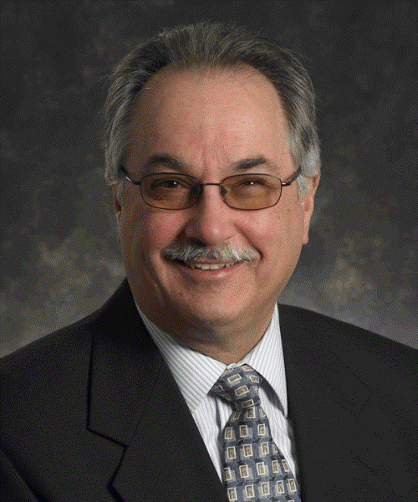
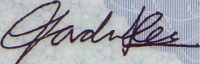
NOTE: You are advised to furnish MISS. AMANDA HOLMES with your correct and valid details, do also be informed that the amount to be paid to you are $280,000.00 USD (Two Hundred and Eighty Thousand United States Dollars Only). We expect your urgent response to this email to enable us monitor this payment effectively thereby making contact with MISS. AMANDA HOLMES as directed to avoid further delay.
CONGRATULATIONS!

SIGN: ……………………………..............................
M MR. DANIEL E. CHARBONNEAU
UN COORDINATOR ON FINANCIAL MATTERS

