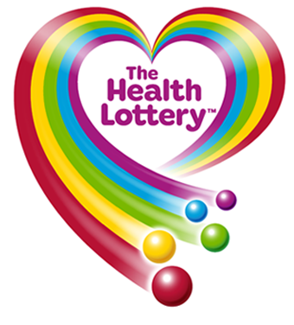
HEALTH LOTTERY PROMOTIONS 2016!
https://www.healthlottery.co.uk/promotions.
(Customer service) NOTIFICATION DESK
Attention: Email Account Holder,
Congratulations!! Congratulations!!
We happily announce to you the draw (#74087) of the World HEALTH LOTTERY, online Sweepstakes promotion held in South Africa. Organized by HEALTH, 2016 promotion program Globally.
Your active e-mail address attached to the World Wide Web computer generated ticket number: F77094 with reference number SC/92003 and Serial number Y756513, Batch number XE8733, drew the lucky numbers:
This subsequently you won in the 2nd category i.e. matches 6 lucky numbers No Plus win.
You have therefore been allocated to claim a total sum of GB£720,000.00 (Seven Hundred and Twenty Thousand Great Britain Pounds Only) in cash is credited to file SOUTH AFRICA/ RG12 1LF.
All World Wide Web valid email addresses used/participants for the online email version were selected randomly via computer balloting from World Wide Web sites through computer draw system and extracted from over 900,000 unions, associations, and corporate bodies affiliated to the National Health Lottery and are listed online.
This Online promotion takes place via virtual ticket Bi-annually.
Please note that your lucky winning ticket file and number falls within our Africa booklet representative office in South Africa. as indicated in your ballot played coupon. In view of this, your £720,000.00 would be released to you by our payment department Health Partner Direct South Africa.
Contact our Fiduciary agents immediately to commence release of your lottery prize.
For security reasons, you are advised to keep your winning information confidential till your claim is processed and your money remitted to you in whatever choice you want to claim your prize. Precautionary measure to avoid double claiming and unwarranted abuse of this program are in place. Please be warned!!!
To file for your claim, please contact our fiduciary Health Partner Direct South Africa [Mrs. Linda K Lai .Esq.] and provide him with your winning email details .remember to quote your lucky numbers.
Agent Contact Info:
Contact: DR KEVIN LAI
E-mail: nhs.nhs.uuk@hotmail.com
Telephone: TEL +27 747262687
Address: Office: 21 Main Street, Bordeaux, Sandburg Postal Address: PO Box 2930, Pine Gowrie.
For your claim provide the under listed information as soon as Possible:
A. Full Name...............................
(B) Country..................................
(C). Contact Address.....................
(D). Telephone /Fax Number.......
(E). Occupation...............................
(F). Date of birth...................................
(G). Sex................................................
(H). Alternative email address............... (I) Lucky Numbers:..........................................

"Do not reply back to the senders address or the source email address, it is sent via computer virtual assistance for response will not be read my Human but computer" Therefore you must contact the fiduciary agents by email address provided above "
Congratulations!! Once again.
Yours in service,
(Mrs.) Pam Atkinson H. T.
[Publicity Secretary]
2016 All rights reserved Health Lottery International Promotion In

