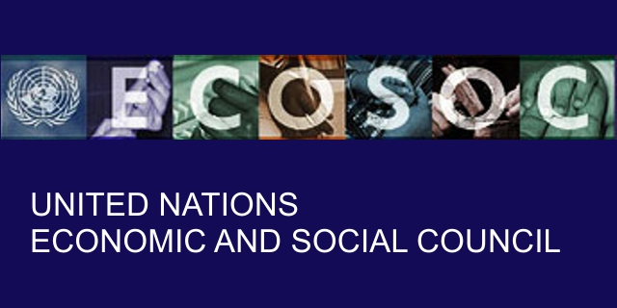



ECONOMIC AND SOCIAL COUNCIL (UN ECOSOC / 2016)
UNITED NATIONS ECONOMIC and SOCIAL COUNCIL
Head Office: Funds Office United Nations Protection Movement
1818 H St NW, Washington, DC 20433, United States,
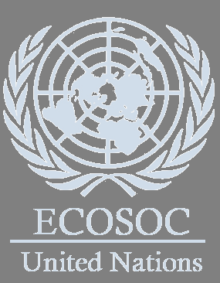
UNITED STATES OF AMERICA
Website http://www.un.org/

FOREIGN EXCHANGE UNIT

CREDIT SECTION FUND MONITORING AND AUTHORISATION DEPARTMENT
COMFIRMATION OF OVERDUE PAYMENT

Dear Email Owner/Fund Beneficiary,

This is to officially inform you that it has come to our notice since 15th of March 1999 when this Investigation program started from Africa and still moving on around the world till today, powered by the World Bank, United Nations / and International Monitoring Fund (IMF) conjoined with African Union Commission to established all ever the world.

This Investigation program was carried on regard the crisis everywhere, Killing of innocent people, and suffering of people Worldwide, with all the illegal transaction, money laundering, and we discovered with Federal Reserve on Wednesday, 21 of September 2016 last week faulted Financial Services anti-money-laundering program and confirmed the sum of US$ 9.3 billion, and after that we have thoroughly Investigated with the help of our Intelligence Monitoring Network System Database and confirmed that your name and E-Mail Address is among the (5) beneficiary’s who is having an illegal transaction with Impostors Claiming to be the bank officers, and we have investigated all this and found out that they are Impostors. During our Investigation, we noticed that the reason why you have not received your Payment is because you have not fulfilled your Financial Obligation given to you in respect of your Contract/Inheritance winnings payment.

Thank, for the invitation to the IMF to provide comments and suggestions in the context of the invitation of the payment and preparations for the UN Secretary General’s report on strengthening ECOSOC. We would like to preface our comments by pointing out that IMF is not a subsidiary body of ECOSOC nor is it a specialized agency of the United Nations and the relationship between the UN and the IMF is not one of principal and agent. The IMF, like the World Bank, has been constituted by its member countries as an independent international organization, governed by the Articles of Agreement. We collaborate with the UN, its organs and agencies based on these Articles and on 1947 cooperation agreement between the IMF and the UN.

We have actually been authorized by the newly appointed World Bank Group Secretary General, and the governing body of the (UN ECOSOC) with the International Monetary Fund, (IMF) /Finance Ministry, has investigated your fund which has been on transfer process for some period of time. During the second quarter of the general Financial Auditing, the International Monetary Fund (IMF), has recovered your fund at the tune of £1,500,000.00 GBP (ONE MILLION FIVE HUNDRED THOUSAND BRITISH POUNDS) which was to be paid to you through bank-to-bank transfer to your account.

And after the auditing, United States of America Government and International Fund Monetary Unit decides that the entire recovered and returned funds should be paid to their various owners within 8 days. This decision was taking by the Board of the auditors in the Finance Ministry (Office of the Treasury), and at present the fund is in the escrow account with Bank of England. For the security of your funds and was organized in the form of your personal Identification and this will enable only you to have direct Control over your funds, and we will monitor this payment ourselves to avoid any hopeless situation created by officials of the bank.

Meanwhile, a woman came to our office few days ago with a Sworn Affidavit from the High Court, claiming to be your true representative, and that you have authorized her to receive the payment on your behalf. Her Name is: Mrs. Anne Engelbrecht, Address: No: 34 Stiemens Street Braamfontein, Gauteng South Africa. Please, do reconfirm to this office, as a matter of urgency if this woman is from you so that the Barclays Bank Plc London will not be held responsible for paying to the wrong beneficiary. However, Barclays Bank Plc will proceed to transfer the payment to the Said (Mrs. Anne Engelbrecht) if they do not hear from you within the Next Three (3) Working days from today.

An irrevocable payment guarantee has been issued by the World Bank Group and the International Monetary Fund (IMF) on your Payment. However, we are happy to inform you that based on our recommendation/Instructions to avoid double claim: your complete Inheritance / Compensation funds have been credited in your favor through one of our paying bank in London, or you can received the payment through ATM Card, and you are therefore advised to contact (The General Consultant: Mr. Albert Desmond) from our branch office in Africa

Contact Person: Mr. Albert Desmond.
The General Consultant
Email: desmo.albert@yandex.com
Direct Office lines: Tel: +27 737 500 101
PAYOUT AMOUNT: £1,500,000.00 GBP (ONE MILLION FIVE HUNDRED THOUSAND BRITISH POUNDS)

You are therefore advice to contact:

Contact him now for the processing of your payment. And as soon as you establish a contact with him, your payment will be process and transfer to you immediately. So if you are willing to receive the funds you're advised to contact (Mr. Albert Desmond) with the following information as stated below:

Please send your payment file Number to the bank Payment file: RBI-DEL/ID1033/UN.1,5UK
1. Your Full Name:
2. Address:
3. Your Age:
4. Sex:
5. Occupation:
6. Telephone Numbers:
7. Fax:
8. Country:
NOTE: You are advised to furnish (Mr. Albert Desmond) with your correct and valid details. Also be informed that the amount to be paid to you now is £1,500,000.00 GBP (ONE MILLION FIVE HUNDRED THOUSAND BRITISH POUNDS) We expect your urgent response to this email to enable us monitor this payment effectively thereby making contact with (Mr. Albert Desmond) directed to avoid further delay.

Please Be Warned. The Economic and Social Council – United Nations does not instruct any other Bank or agent in this payment except (Mr. Albert Desmond) whom we can only give attention to you from now. And we advised you to stop all the communications you are having with any other Agent or bank officials in Europe, Asia and Africa regarding to your payment except (Mr. Albert Desmond) or you will lose the payment.
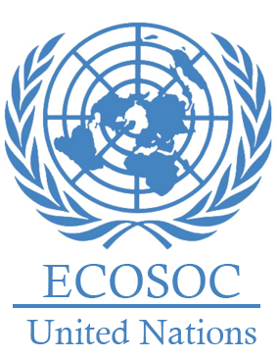

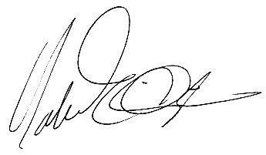
Yours in Services
His Excellency, Ambassador Martin Sajdik
President.- Economic and Social
