
o



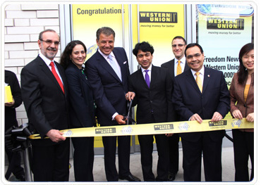


YOU’RE WINNING FILE NUMBER (/SA/6669/2016).

A Division of financial Service provider.

We are Celebrates our 161 Annual Anniversary 2016; we rolled out over USD$16, 000, 000, 00 (Sixteen Million United State Dollars) for our 161st Anniversary draws. All participants were selected through computer ballot system drawn from 25,000,00 company email address, and 30,000,00 individual email address from over 40 networks from Australia, new Zealand, North America, South America Europe, all Asia and Africa as part of International promotion held in South Africa Pretoria Johannesburg.

We officially Announce to you that your email address has just Won the sum of USD$600, 000, 00 (Six Hundred Thousand United State Dollars) to begin the verification process of your prize; you are required to forward your bank account details to the transferring manager for Option( 1) or option (2 )

The Claim Transferring Agent Contact Details as Fellow
Name: Mr. Fred Richard
Email: handoffice2016@yandex.com
Telephone: +27 72565 4949.

You should establish contact with redeeming transferring manager via email or telephone with the particulars presented bellow for immediate payment to your bank account; please remember to quote your winning file number and your winning transferring identification code in your correspondence to her.

Payment Option# 1
Electronic Wire Transfer
1. Bank Name:
2. Beneficiary:

3. Account Number:
4. Bank Address:
5. Swift Code or Routing Number:
6. Your Mobile Telephone Number:
7. Date of Birth:
8. Occupation:
9. Country:
10. Sex:
11. Alternative email:

Payment Option# 2
Western Union ATM Master Card
Full name......
Address.........
Age................
Sex...................
Country/Nationality.........
Home Telephone #......
Mobile Telephone #........
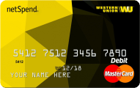
You will be contacted by western union transferring manager in the nest 24hours as soon as you forwarded your required bank account information to her for the transfer.
Save time, send money, earn rewards! Western Union is a service people trust.
ANNIVERSARY DAY
YOUR WINNING TRASFER IDENTIFICATION CODE (WUNT/768/SA/
Thank You for Using Western Union!

