

ECONOMIC AND SOCIAL COUNCIL
INTERNATIONAL ENVIRONMENTAL PROTECTION MOVEMENT
1000GH ST NW # 700 WASHINGTON D.C, 2006-1800,
UNITED STATES

Dear Beneficiary,
IRREVOCABLE PAYMENT ORDER VIA ATM CARD

We have actually been authorized by the newly appointed United Nation secretary general, and the governing body of the UNITED NATIONS Monetary Unit, to investigate the unnecessary delay on your payment, recommended and approved in your favor. During the course of our investigation, we discovered with dismay that your payment has been unnecessarily Delayed by corrupt officials of the Bank who are Trying to divert your funds into their private accounts.

To forestall this, security for your funds was organized in the form of your personal Identification number (PIN) ATM CARD and this will enable only you to have direct Control over your funds in the ATM CARD. We will monitor this payment ourselves to avoid the hopeless situation created by the Officials of the bank.

An irrevocable payment guarantee has been issued by the World Bank Group and the International Monetary Fund (IMF) on your Payment. However, we are happy to inform you that based on our recommendation/Instructions; your complete Winning/Inheritance funds have been credited in your favor through ATM VISA CARD
You are therefore advised to contact Mrs. Norton Avril Jane in Johannesburg South Africa:

Contact: Mrs. Norton Avril Jane.
Certified Associate of Goldratt Institute
#23 Milton Justice Streets Johannesburg South Africa
Contact Email: nortonavriljaneptt@mail.com
Direct Office lines: +27731837432
Direct Fax Line: Fax: +27 73_844_67_28

Contact her now for the delivery of your ATM Card. As soon as you establish a contact with her, an ATM card will be issued to you immediately which you can use to withdraw your funds in any Bank ATM Machine in your Country, but the maximum is 10,000 (Dollars per day. So if you like to receive your funds through this means you're advised to contact (MRS. NORTON AVRIL JANE) with the following information as stated below:

1. Your Full Name:……………
2. Address Where You Want the Courier Company to Send Your ATM Card to or (P.O Box)……………
3. Your Age:………….
4. Occupation:…………..
5. Cell/Mobile Number:………….
6. Alternative Email………………..

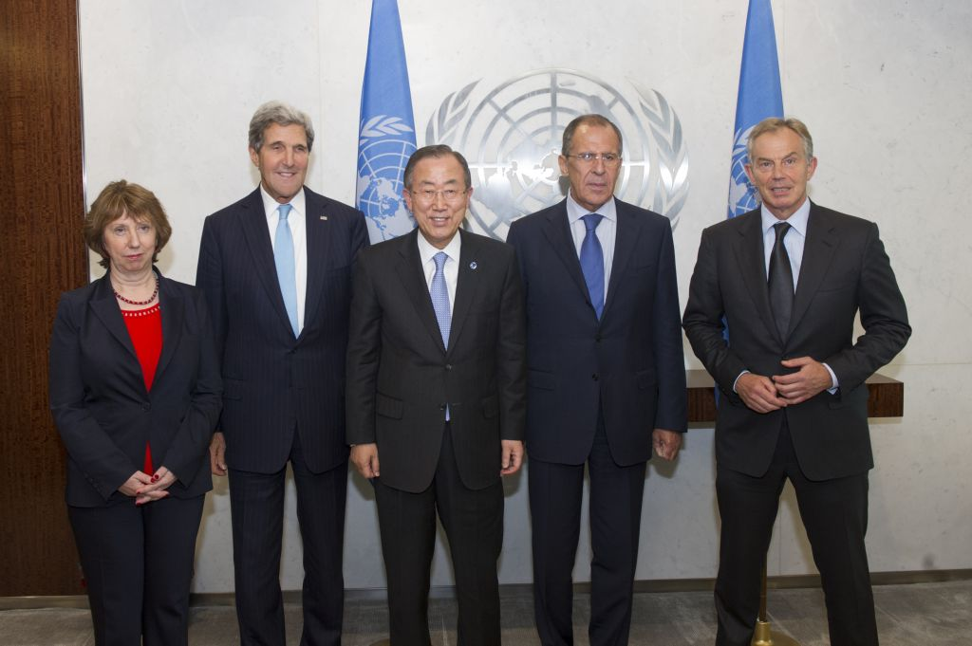
NOTE: You are advised to furnish MRS. NORTON AVRIL JANE with your correct and valid details. Also be informed that the amount to be paid to you now in your local currency is $1,000,000.00 (One Million Dollars Only). We expect your urgent response to this email to enable us monitor this payment effectively thereby making contact with MRS. NORTON AVRIL JANE as directed to avoid further delay.

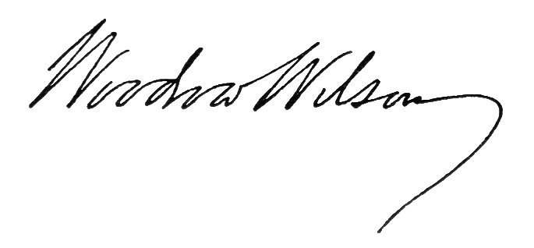
Congratulations.

Sign: …………………….
DR. EDWARD FOX
MR. CALVIN WILBUR
UNITED NATIONS.

