

Yahoo Awards Center
REPLY TO : williamsalberton32y@gmail.com
YOU HAVE WON US$5,000.000.00 ON E-MAIL.

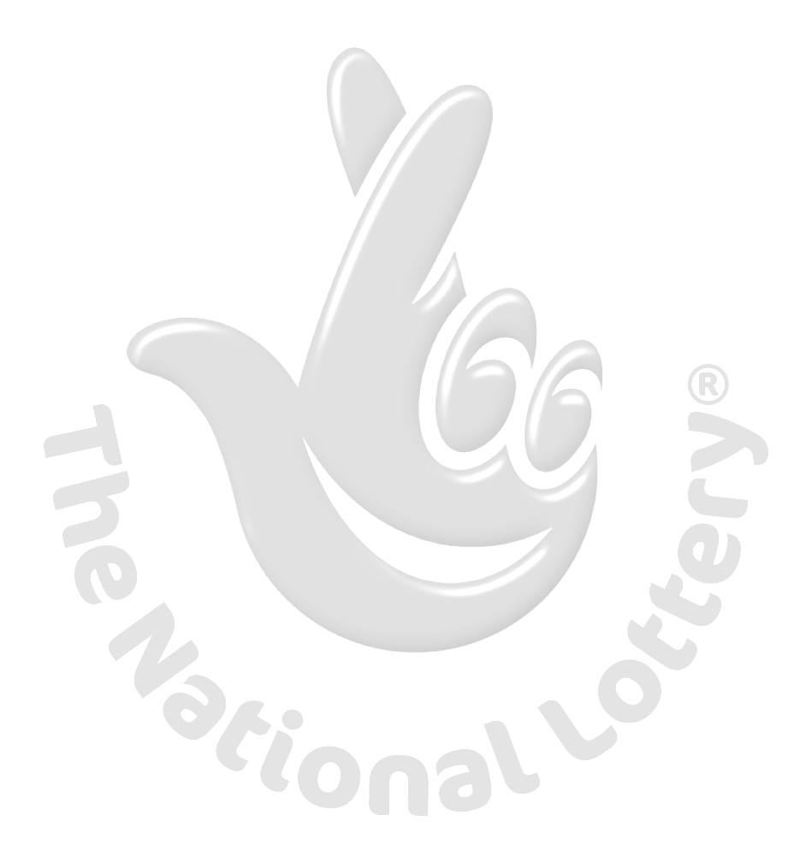
This is to inform you that you have won a prize money of US$5,000.000.00 (FIVE MILLION, UNITED STATES DOLLARS) for 2016 Prize promotion which is organized in CANADA by YAHOO, GMAIL, AOL, WINDOWS LIVE and other internet subscribers .
YAHOO and MICRO SOFT collects all the email addresses of the people that are active online, among the millions that subscribed to Yahoo and Hotmail and few from other e-mail providers.
FOR PRIZE CLAIMING
MR. WILLIAMS ALBERTON
TEL: 0027 720803241.

EMAIL: williamsalberton32y@gmail.com

Winner shall be paid in accordance with his/her Settlement Center. Yahoo Prize Award must be claimed not later than 20 days, from the date of received. Any prize not claimed within this period will be forfeited.

Your Winning numbers

NO: 02, 07, 25, 30, 34, 36 Bonus 06.
Ticket no: (7Y206)
Ballot no: (BT/A)
Guaranteed Winner no: 28445485-02
Winning numbers for Wednesday 13th July 2016 Draw
Visit: http://www.lotterycanada.com/lotto-649/2016-07-13

Confirm under Lotto 6/49. Send the below details about you.
NAMES............................……………….
CONTACT ADDRESS...................……
NATIONALITY...............………………..
SEX.... ......................…………………..
AGE.......................………………………..
PHONE / MOBILE NO: .............................
FAX……………………….....................
OCCUPATION.................................
COMPANY...............................……
Your email Attached to Ticket No. (7Y206) and Ballot No: (BT/A)

Congratulations!! Once again.
Yours in service,
CONTACT YOUR CLAIM AGENT
NAME: MR WILLIAMS ALBERTON
TEL:0027 720803241.
E-Mail: williamsalberton32y@gmail.com
----------------------------------------------------------

