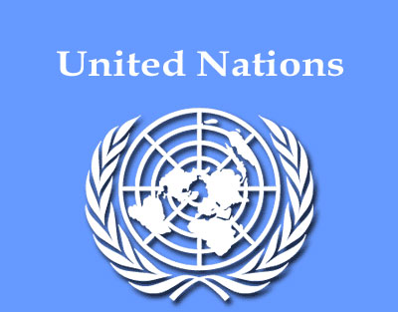

UNITED NATIONS ORGANIZATION
Dear Email Owner/Fund Beneficiary,

IRREVOCABLE PAYMENT ORDER BY ATM VISA CARD OR BANK TO BANK TRANSFER
We have actually been authorized by the appointed United Nation Secretary General, and the governing body of the United Nations Monetary Unit, to investigate the unnecessary delay on your payment, recommended and approved in your favor. During the course of our investigation, we discovered with dismay that your payment has been unnecessarily Delayed by corrupt officials who are trying to divert your funds into their private accounts.

To forestall this, security for your funds was organized in the form of your Personal Identification Pin Number, which is (UN7765138) and this will enable only you to have direct control over your funds. We will monitor this payment ourselves to avoid the hopeless situation created by the corrupt officials appointed by United Nations Financial Committee previously.

An irrevocable payment guarantee has been issued by the World Bank Group and the International Monetary Fund (IMF) on your Payment. However, we are happy to inform you that based on our recommendation and instructions; your complete Inheritance Funds will be credited in your favor according to your wish, once you establish a total communication with the fund releasing manager.

YOU ARE THEREFORE ADVICE TO CONTACT HER IMMEDIATELY:

RELEASING MANAGER
DR. PETUNIA CUTHBERT
DIRECT OFFICE LINE: +27 63 220 6721
DIRECTOR ATM PAYMENT DEPARTMENT
EMAIL ADDRESS: dr.petucuthbert@financier.com

Contact her now for the delivery of your ATM VISA CARD or your introduction on how you want to claim the fund. As soon as you establish communication with her, she will be in a better position to listen to you and also agree with you on the best form how you will want to receive your Inheritance Funds of $375,000.00 USD. Remember if you choose to receive this Inheritance Funds of $375,000.00 USD by ATM VISA CARD, it will be issued to you immediately which you can use to withdraw your funds in any Bank ATM Machine in your Country, but your withdrawing limit per day will be $2,000.00 USD.

So if you would like to receive your funds through this means of ATM VISA CARD or through BANK TO BANK TRANSFER you are advised to contact (DR. PETUNIA CUTHBERT) with the requested below information:

PROFESSION:
DATE OF BIRTH:
YOUR FULL NAMES:
YOUR FULL ADDRESS:
YOUR MOBILE NUMBER:
YOUR TELEPHONE NUMBER:

NOTE: You are advised to furnish Dr. Petunia Cuthbert with your correct and valid details. Also be informed that the amount to be paid to you is $375,000.00 USD. We expect your urgent response to this email to enable us monitor this payment effectively thereby making contact with Dr. Petunia Cuthbert as directed to avoid further delay.
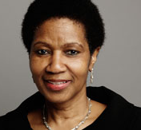
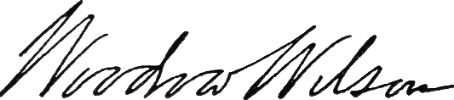
MRS CONGRATULATIONS!

SIGN: ……………………………...
MRS. JOY MS PHUMZILE MLAMBO-NGCUKA
UN WOMEN EXECUTIVE DIRECTOR

