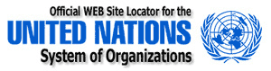

ECONOMIC AND SOCIAL COUNCIL

OHCHR ADDRESS:

OFFICE OF THE UNITED NATIONS HIGH COMMISSIONER FOR HUMAN RIGHTS (OHCHR)

PALAIS WILSON 52 RUE DES PÂQUIS CH-1201 GENEVA, SWITZERLAND.

IRREVOCABLE PAYMENT ORDER
Greetings,

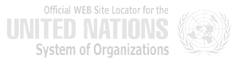
Office of the UNITED NATIONS HIGH COMMISSIONER FOR HUMAN RIGHTS (OHCHR) has investigated why you have not yet received your funds.

The World Bank Group and the International Monetary Fund (IMF) have issued an irrevocable payment guarantee in your favor today.

In which United Nations for Human rights and International Monetary Fund (IMF) European Cooperate Office have received all the overdue outstanding payment owed to the following firms, Contract, Inheritance Next of Kin and Lottery Beneficiaries that was originated from Europe, Americans, African, Asian Including Middle East. And to reconcile all debts on foreign Contractor who was swindled by Fraudster/Scammers.

We are about to release your compensation payment via ATM MASTER GOLD CARD which is functional in any ATM Machine in the world with the use of your pin code. This compensation is for those who are selected from scam victim list on our database. Your name is among of 367 Victims listed to be compensated by World Bank/IMF via ATM CARD with Reference Number: BK/ATMSCXX0X5X9X3X16 valued payment of US$1,500,000.00 (ONE Million, Five Hundred Thousand United States Dollars Only) has been unnecessarily delayed by corrupt officials of the Bank who are Trying to divert your funds into their private accounts.

To forestall this, security for your funds was organized in the form of your personal Identification and this will enable only you to have direct Control over your funds in your bank account. We will monitor this payment ourselves via IN JOHANNESBURG to avoid the hopeless situation created by officials of the bank.

You are therefore advice to contact your claim agent below;

CONTACT PERSON: MR.ADAMS MACINTYRE
PHONE: +27729690483
E-mail: adams.macintyre2016@yandex.com
AMOUNT in ATM CARD: US$1,500,000.00

But daily Withdraw Limit would be US$15000 or its equivalent to any currency depend which nation you reside presently. If you like to receive your fund these ways please let us know by contacting the card payment centre and also send the following information:

1. Your Full Name:
2. Address
3. Telephone Numbers:
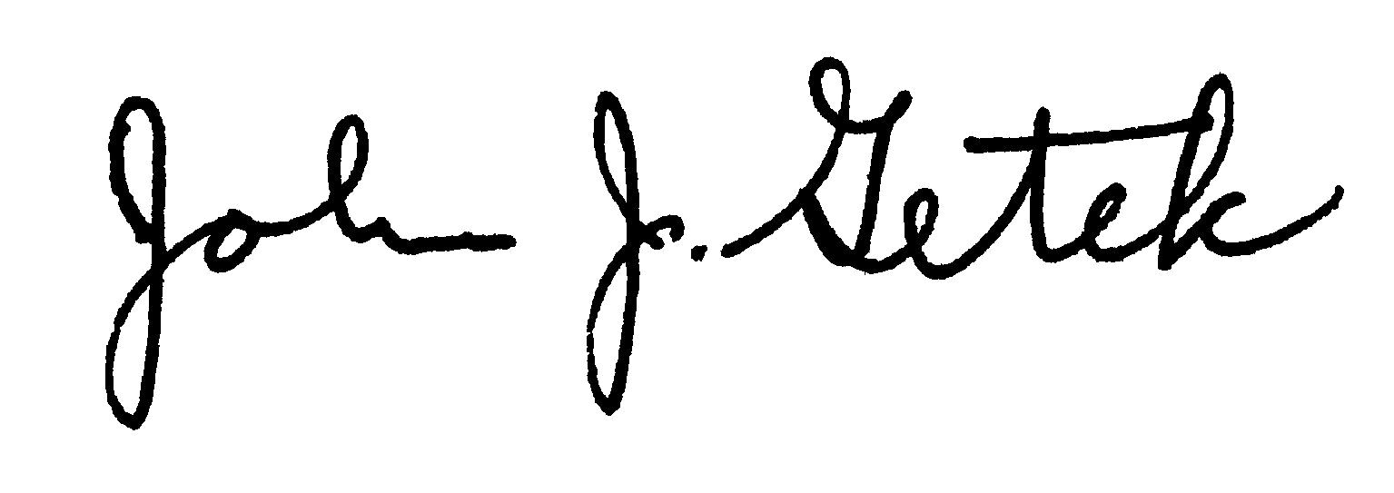
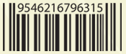
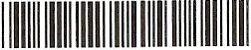
Yours sincerely

DR. JOHN AXILLA
UNITED NATIONS OFFICE

NOTE: Please Be Warned The United Nations Anti-Crime Commission and the International Monetary Fund (IMF) does not instruct any other Bank or agent in this payment except DR. MICHAEL MALAKASA), whom we can only give attention to, and from now, we advise you to STOP ALL THE COMMUNICATIONS YOU ARE HAVING WITH ANY OTHER AGENT OR BANK OFFICIALS IN EUROPE, ASIA AND AFRICA REGARDING YOUR PAYMENT, OTHWISE YOU WOULD BE WASTING YOUR MONEY TO SWINDLERS, CONTACT MR.ADAMS NOW ASAP

