

YAHOO AWARD www.lottery.co.uk
124 Stockport Road, Long sight, Manchester M60 2 DB-United Kingdom.

This is to inform you that you Email have won a prize money of One Million British Pounds (£1,000,000.00) for 2016 Prize promotion which is organized by British Micro-Soft Award. MICRO SOFT collects all the email addresses of the people that are active online, among the millions that subscribed to Yahoo and Hotmail and few from other e-mail providers. Six people are selected every two years to benefit from this promotion and you are one of the Selected Winners.
PAYMENT OF PRIZE AND CLAIM.
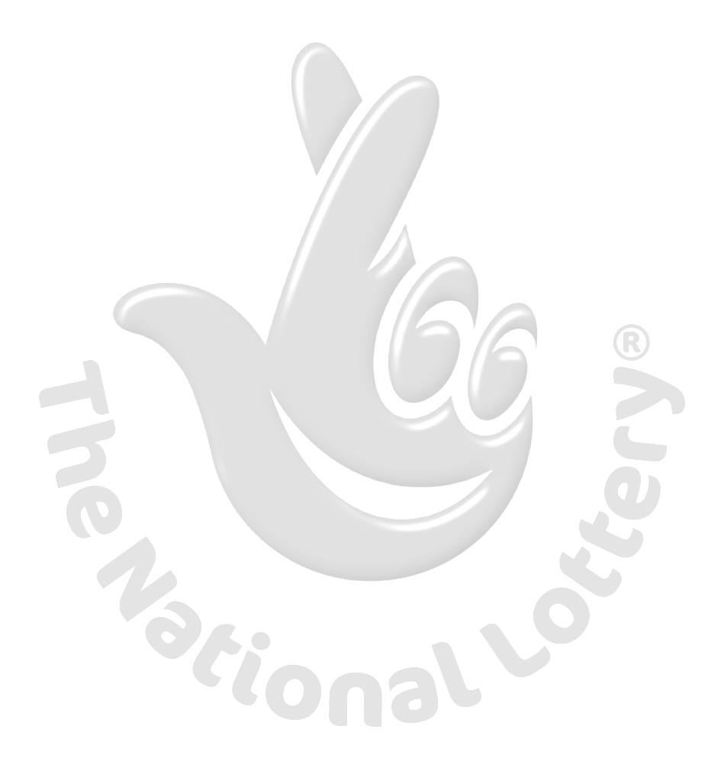
Winners shall be paid in accordance with his/her Settlement Center. Yahoo Prize Award must be claimed no later than 28 days, from date of Draw Notification. Any prize not claimed within this period will be forfeited. Stated below are your identification numbers: BATCH NUMBER: YPB/08/APA-43658, REFERENCE NUMBER: 28234522, WINNING NUMBER: 17 21 31 38 44 58 (20).These numbers fall within the Johannesburg Location file, you are requested to contact our fiduciary agent in Johannesburg South Africa and send your winning identification numbers to him:

CLAIMS MANAGER CONTACT INFORMATION:
NAME: Dr. JAMES ADAMS
E-Mail: drjamesadams1@yahoo.co.za
TEL: +27 748 044 206
FAX: +27 866 012 076

You are advised to send the following information to your Claims Agent to facilitate the release of your fund to you.
1. Full name…………………………….
2. Contact Address……………………
3. Country of origin…………………..
4. Country of Residence…………….
5. Telephone Number………………..
6. Fax Number………………………….
7. E-mail………………………………….
8. Age…………………………………….
9. Sex…………………………………
10. Occupation…………………………..
11. Batch Number………………………
12. Reference Number…………………
13. Winning Number……………………….
Congratulations!! Once again.
Yours in service,
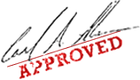
(Mrs.) Mercy Martins

