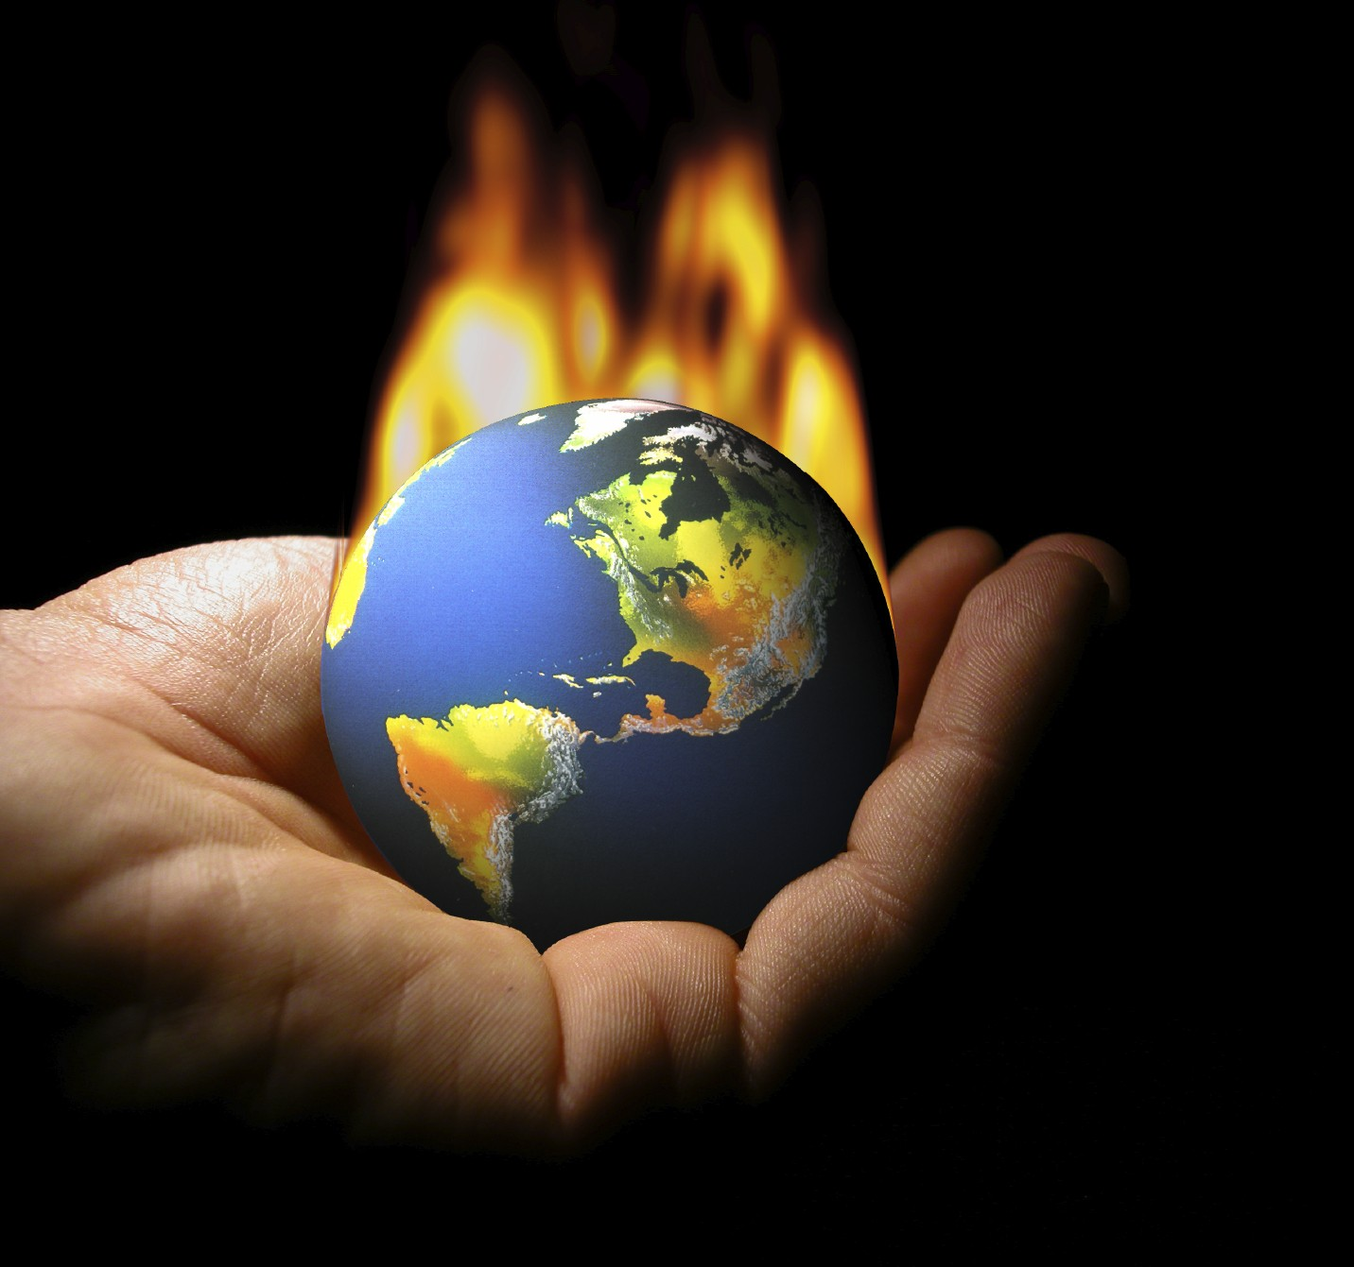
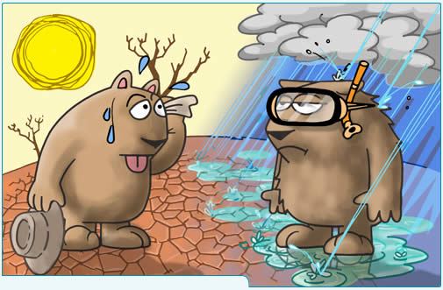
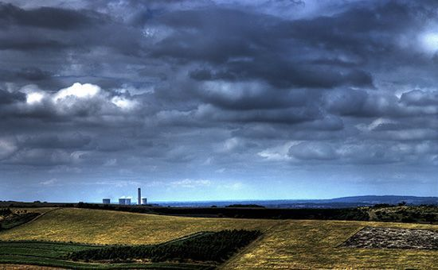
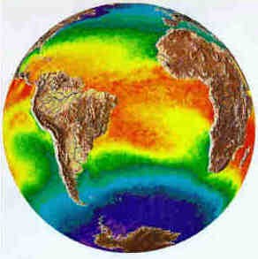
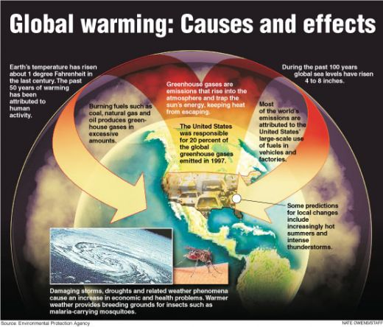

PLEASE HELP PROTECT/SAVE OUR PLANET.
United Nations Framework Convention on Climate Change (UNFCCC) in Collaboration with the Nelson Mandela Foundation (NMF) AND WILLIAM J. CLINTON FOUNDATION.

Attention: Sir/Madam,

This is to inform you that the United Nations Framework Convention on Climate Change (UNFCCC) in Collaboration with the Nelson Mandela Foundation and William J. Clinton Foundation has held an Internet Raffle Draw, and your Email Address was among the 2011 Email Addresses that was picked through the computer ballot system. The United Nations Framework Convention on Climate Change/Nelson Mandela Foundation and William J. Clinton Foundation was conceived with the objective of human growth, educational and community development to create awareness to the dangers posed on our planet by climate change.

To celebrate the 18th anniversary of the United Nations Framework Convention on Climate Change (UNFCCC), the United Nations Framework Convention on Climate Change /Nelson Mandela Foundation and William J. Clinton Foundation in conjunction with the United Nations (UN) and the European Union (EU) & United Kingdom LIVE PROMOTION CENTER, Office Complex: 200 Tolpits Lane, Watford, Herts WD18 9RN - United Kingdom is giving out a yearly donation of £950,000.00 { Nine Hundred and Fifty Thousand British Pounds Sterling’s Only} to 7 lucky recipients.

These specific Donations will be awarded to 7 lucky international recipients worldwide in different categories for their personal business development and enhancement of their educational plans and to create awareness in their community on the dangers posed on our planet by climate change as a Result of pollution. Recipients are only eligible to be awarded this donation once. We therefore with great pleasure notify you that your email address happened to be among the seven email addresses selected for this Donation.

BELOW IS YOUR WINNING INFORMATION.
EMAIL CODE NUMBER: UNFCCC/18/NMF/11
BATCH NO: (N-222-6747,E-900-56)
AMOUNT WON: £950,000.00
It is now agreed and endorsed by the United Nations Framework Convention on Climate Change (UNFCCC) / Nelson Mandela Foundation (NMF) and William J. Clinton Foundation that the winning information as written above are correct as was selected by the computer ballot system and it has been agreed that the winner whose winning information has been sent to the Paying Bank, will be paid the sum of £950,000.00 { Nine Hundred and Fifty Thousand British Pounds Sterling’s Only}.

PRIZE CLAIMING INSTRUCTION:
Please do contact our consultant and furnish him with the following information:
1. Full name........................
2. Country...........................
3. Telephone Number...........
4. Date of birth....................
5. Occupation......................
6. Please note that a copy of your passport or your drivers license is needed while sending your information
Contact Person: Mr. Richard McCoy
Tel: +44 703-174-8778
Fax: +44 871 5036241
Email: richard-mccoy1@hotmail.co.uk
Email: richard-mccoy2@hotmail.co.uk
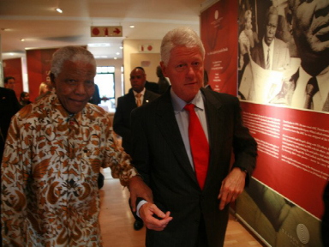
You are by all means hereby advised to keep this whole information confidential until you have been able to collect your donation, as there have been cases of double and unqualified claim, due to beneficiaries informing third parties about his/her donation. Finally, all funds should be claimed by their respective beneficiaries, not later than 14 days after notification. On behalf of the Board kindly, accept our warmest regards.

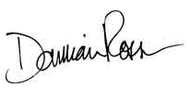
Yours Sincerely,

Damian Chipman
Foundation officer.
PLEASE HELP PROTECT/SAVE OUR PLANET.

